1. 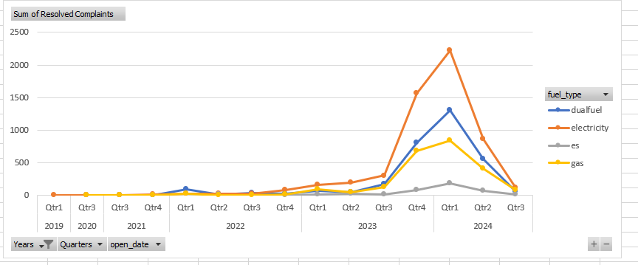**METABASE**

SELECT

count("sp_reporting"."complaint_tracker_journey"."complaint_number") AS "Resolved Complaints",

"sp_reporting"."account"."fuel_type",

"sp_reporting"."complaint_tracker_journey"."open_date"

FROM

"sp_reporting"."customer",

"sp_reporting"."account",

"sp_reporting"."complaint_tracker_journey"

WHERE

"sp_reporting"."customer"."account_selection_journey_id" = "sp_reporting"."account"."account_selection_journey_id" AND

"sp_reporting"."customer"."account_selection_journey_id" = "sp_reporting"."complaint_tracker_journey"."account_selection_journey_id" AND

"sp_reporting"."complaint_tracker_journey"."status" = 'RESOLVED'

GROUP BY

"sp_reporting"."complaint_tracker_journey"."open_date",

"sp_reporting"."account"."fuel_type"

ORDER BY

"sp_reporting"."complaint_tracker_journey"."open_date" ASC;